The Fantastic Secret of Owen Jester
Written by Barbara O’Connor
Published by Farrar Straus Giroux
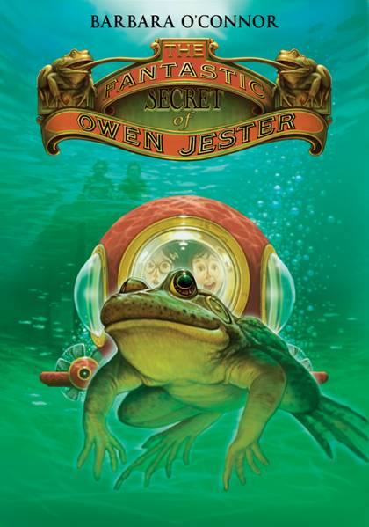

A Reader’s Theatre Script
Adapted by Debbie Gonzales

The Fantastic Secret of Owen Jester
Chapter 10

List of Characters:
Narrator
Owen Jester – middle grade aged protagonist, active, enjoys the outdoors, adventurous
Travis – Owen and Stumpy’s friend
Stumpy – Friend of Owen and Travis
Viola – irritatingly nosey neighbor Owen’s age

Setting:
Grassy, sloped hillside beside a train track near some woods leading to a large pond.

Presentation:
Narrator: Owen found something.
Owen: (Dramatize observing a strange discovery)
Narrator: He walked around it, studying it carefully. There was an enclosed compartment with three large windows in the front and one round, bubble-shaped window on each side.
In the back of the enclosed compartment was a hollowed-out space. Strapped inside the space were four large tanks, like the kind that scuba divers use.
Owen: (Excitedly) A submarine!
Narrator: Owen peered through the windows. Inside was an instrument panel with a few glass-covered dials, some switches, and a joystick. In front of the instrument panel were two small seats.
Owen: A submarine just big enough for two people!
Narrator: Owen’s heart was racing.
Owen: Wait…just wait…until Travis and Stumpy see this!
Narrator: Later Owen, Travis and Stumpy dashed across the yard toward the woods eager to see what Owen had found.
Then…
Viola: Where y’all going?
Narrator: Viola’s voice sliced through the air.
Owen stopped.
Owen: (Shocked expression)
Narrator: Travis and Stumpy stopped.
Travis: (Disgusted expression)
Stumpy: (Shocked expression)
Narrator: Owen wondered why, why, why did Viola always have to show up at the wrong time?
Owen: (Scowling)
Narrator: Owen had wanted to surprise Travis and Stumpy with the submarine. But now Viola was there, ruining everything like she always did.
Owen: (Glancing at Travis and Stumpy, as if to share a secret) We’re going to the pond to catch some snakes. Wanna come?
Viola: (Hands on hips…defiantly) You are not!
Travis: We are, too. And we’re doing to dig up some big, fat slimy worms for Owen’s bullfrog, Tooley. Those slimy gray one that live in the mud down there by the pond.
Viola: (Narrow eyes. Scowl.) Fibber.
Owen: (Anxiously bouncing from foot to foot.) Come on with us, Viola. You can stick your arm down in the water and touch Tooley. If you’re lucky, you won’t get any leeches stuck on you.
Viola: (Flatly, arms folded over chest) There are no leeches in that pond.
Owen: (Rolling eyes) You think you know everything, but you don’t.
(Nodding toward Travis) Tell Viola about the leeches.
Travis: (Stares at Owen)
Owen: (Winks a tiny little wink to Travis) You know…the leeches?
Travis: (Dramatically) Oh! You mean them nasty, slimy, squishy, juicy leeches that stick on you and suck all your blood out?
Owen: (Nod solemnly) Yep….that’s the ones.
Travis: Oh…there’s leeches down there all right. Gerald Asher’s brother went fishing down there once and got a leech this big stuck on him. (Hold hands out about a foot apart. Then widen them a bit…and then a little bit more, then lastly open to full arms’ length wide.)
Stumpy: (Snorts in laughter)
Owen: (Shoots Stumpy a stern look)
Stumpy: (Muffle a laugh)
Viola: (In a know-it-all voice with one hand on hip and head cocked) Y’all must think I’m stupid.
Owen: We might even feed some leeches to Tooley.
Viola: (Snarling) Bullfrogs don’t eat leeches, Besides your frog does not want to be named Tooley. Trust me. (Angrily brush a strand of hair from face) And your frog should not be living in a cage.
Narrator: Owen couldn’t stand it another minute. The only thing left to do was shout the code word for rapid escape from a wretch like Viola.
Owen: (Shouting) ROCKET!
Narrator: And all three boys scrambled up the grassy bluff momentarily away from the submarine, Tooley, and…most especially…Viola.

