OH, NUTS! by Tammi Sauer, illustrated by Dan Krall
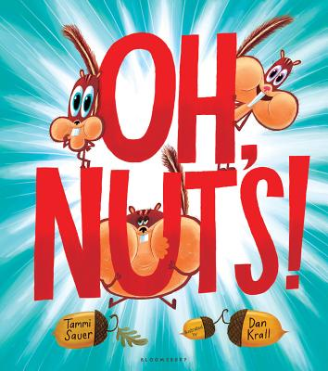
Have you ever been to the zoo and seen the chipmunks running amok? Darting up trees? Whooshing through the grass? Zipping over branches and sidewalks? But do you ever stop and pay them any attention? No. You’re too busy snapping photos of the tigers and elephants and giraffes, aren’t you? Well, that’s what happens to Cutesy, Blinky and Bob in Oh, Nuts! Poor, poor chipmunks!
Sauer’s imagination cracks open a tale about three friends working together to flash a little love and affection in their direction. Cutesy thinks they need a makeover, Blinky thinks music is the answer and Bob is content to just follow along. But when their efforts fail to attract zoo-goers, a miracle ensues; Bob gets an idea. An idea so grand—paparazzi swarms them. It’s a good thing these chipmunks think fast on their feet! Krall’s illustrations shine vividly and heighten the humor. A crowd pleaser for ages 3 and up.

